**window.document or document is itself a node object**

So it also has got some important handy properties or methods

they are of DOCUMENT_NODE node type

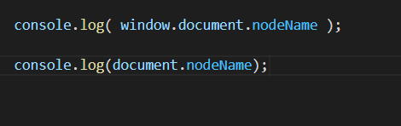



This might be helpful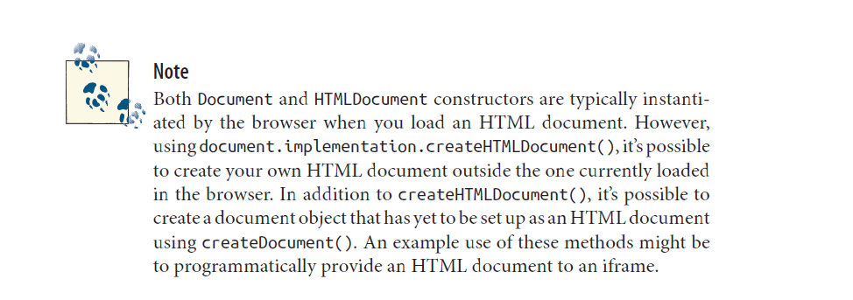

These are few of the properties and methods of the document node

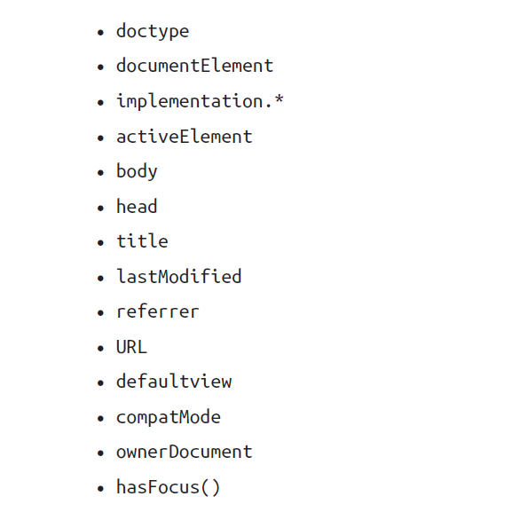

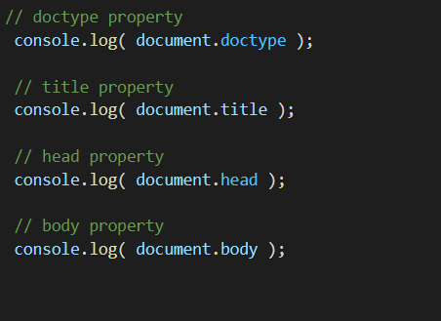

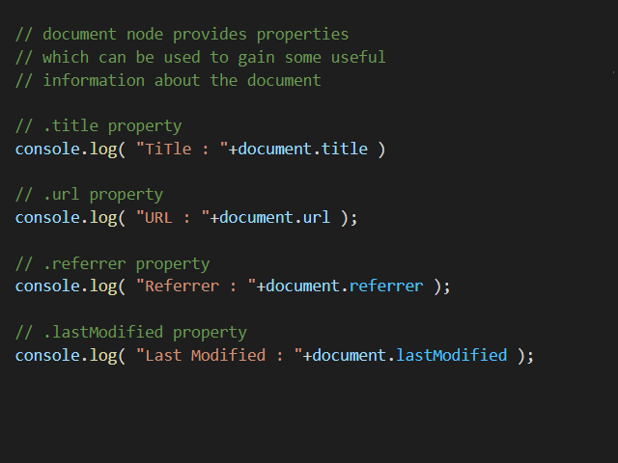

The document node containsonly two child nodes

